



This application is hosted on GitHub at the following link:

<https://github.com/WolvenFlames/pca-thesis>

In order to execute the application, download the .zip file on an Apple computer, unzip the files, and open the project in Xcode. Run the project in the iOS Simulator using the iPhone 6 option.

The test account currently in use is:

Username: test11

Password: pass

When attempting to sign in with these credentials, if an error message pops up, it is likely that the Catalyze account linked to the project has expired. You will need to create a new free trial account with the appropriate database settings. In order to do so, go to [the Catalyze website](https://catalyze.io/) and create a new account for yourself. Then, select the “New Application” option and enter the following information:

Application Name: pca-thesis

Application Description: Palliative Care Application  
Organization: (you’ll be prompted to create one – once you do, select it here)

Once your application has been created, you need to configure it to correspond to the settings used in the Palliative Care Application. Click on the “pca-thesis” Application and view the “API Keys” section. Click on “Add API Key” and enter the following information:

Type: ios

Identifier: pca

This will generate a unique key, which you will later include in the project itself. Now go to the “Custom Classes” section. You will be creating two custom classes, which represent the information transferred between the Palliative Care Application and Catalyze. Click “Add Custom Class” and enter in the following information:

Class Name: esasEntry

Entry Name: pain Type: double

Entry Name: activity Type: double

Entry Name: drowsiness Type: double

Entry Name: nausea Type: double

Entry Name: anxiety Type: double

Entry Name: weakness Type: double

Entry Name: appetite Type: double

Entry Name: depression Type: double

Entry Name: shortness_of_breath Type: double

Entry Name: other Type: double

Entry Name: urgent Type: double

Entry Name: timestamp Type: string

Entry Name: doctor Type: string

Entry Name: doctors Type: object

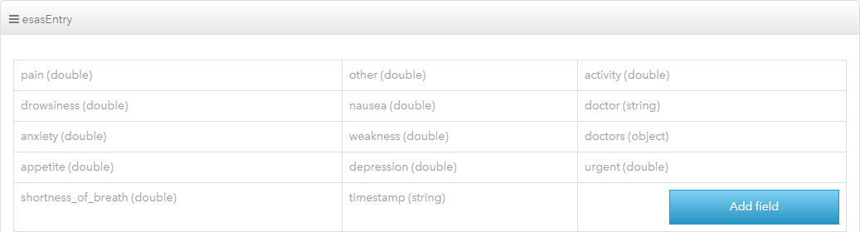

Now create a second custom class with the following information:

Class Name: userTranslation

Entry Name: userId Type: string

Entry Name: lastName Type: string

Entry Name: firstName Type: string



Now go back to the “API Key” section and make note of the API Key and the Application ID (up at the top of the page). If the project is not already open in Xcode, open it and navigate to the AppDelegate.m file. Use the Find command to jump to the part of the code with “ios pca”. It should look something like this:

[Catalyze setApiKey:@"ios pca dd1bd6cf-c295-410f-bdca-f1b8b12e4f67" applicationId:@"aab508da-a96d-4fb5-86a0-9a75ba3e786e"];

Replace the API key and the Application ID with the new ones you just created.